ACCOMPLISHMENT REPORT
IT 205 & 205L –Geographic Information Systems
Month: October – Year: 2025
School Year: 2025 – 2026 1st Semester

DATE | ACCOMPLISHMENT | REMARKS  (Progress and deviations from the plan) *
October 1 – 11, 2025 | Reviewed key concepts from Creating Maps (importing vector data, symbology, labeling, print layout) to reinforce students’ understanding of map design and cartographic elements.  Lecture Accomplishments:  - Conducted a focused review of Module 2: Visualizing Spatial Data, emphasizing table joins, data normalization, and choropleth mapping as tools for meaningful thematic visualization.  - Analyzed sample datasets where students identified which attributes are suitable for normalization and choropleth mapping, discussing common pitfalls in classification and color scheme selection.  - Facilitated a short concept-check session (Q&A and board work) where students explained, in their own words, how joining tables and normalizing data improve map interpretation.  Laboratory Accomplishments:  - Conducted hands-on review exercises on performing table joins between spatial layers and attribute tables, ensuring students can correctly relate geographic features and tabular data.  - Guided students through data normalization tasks (e.g., converting raw counts to rates or percentages) and observed how these affect choropleth outputs.  - Enabled students to recreate and refine choropleth maps from previous activities, focusing on appropriate classification methods and symbology that clearly communicate spatial patterns. | Accomplished  (Modules 1 and 2 were systematically reviewed as preparation for the midterm examination, with emphasis on correct use of joins, normalization, and choropleth mapping.)
October 13 – 17, 2025 | Lecture Accomplishments [Examination Week]:  - Administered the Midterm Written Examination covering:  - QGIS interface and configuration,  - Vector data and symbology,  - Labeling and map layout,  - Table joins, data normalization,  - and principles of thematic/choropleth mapping (Modules 1 and 2).  - Implemented standard exam protocols (instructions, seating, time management, academic integrity reminders).  - Checked and recorded midterm written exam scores, identifying common strengths and misconceptions for follow-up discussions.  - Provided brief post-exam feedback, giving general comments on performance and clarifying frequently missed questions.  Laboratory Accomplishments:  - Conducted the Midterm Practical/Laboratory Examination, where students produced a choropleth map from a given dataset, including correct table join, normalization, classification, and layout elements (legend, scale bar, north arrow, title).  - Observed and documented students’ ability to operate QGIS independently, apply proper symbology, and export final outputs in an appropriate format (e.g., PDF/PNG).  - Collected and evaluated lab exam outputs based on technical correctness, cartographic quality, and completeness of map elements.  - Recorded midterm lab scores and prepared sample outputs as proof/evidence of performance. | Accomplished  (Midterm written and practical examinations for Modules 1 and 2 were successfully administered and evaluated according to the course syllabus.)
October 20 – 24, 2025 | Lecture Accomplishments:  - Officially introduced Module 3: Heat Map, presenting the intended learning outcomes (understanding spatial density, preparing point datasets, generating and interpreting heat maps).  - Explained the concept of spatial density and hot spots, and how heat maps differ from choropleth maps in terms of data type and visual emphasis.  - Discussed examples of real-world applications of heat maps, such as crime hotspots, service demand, incident clustering, and environmental monitoring, linking to sustainable and ethical use of GIS.  - Introduced the requirements for point-based datasets (XY coordinates, attribute fields, and projection considerations) that will later be used for heat map creation in QGIS.  Laboratory Accomplishments:  - Guided students in preparing point datasets for heat map analysis (e.g., loading CSVs with XY coordinates, setting proper CRS, verifying attribute fields).  - Conducted a basic hands-on activity where students added point layers to QGIS and verified the correctness of their spatial distribution (visual inspection, attribute table checking).  - Demonstrated the initial steps for generating a heat map using the QGIS heatmap tools/renderer, but limited the activity to exploratory outputs to leave advanced styling for November.  - Encouraged students to reflect on potential case-study scenarios (e.g., local incidents, service access points) where heat maps could be applied, to be developed further in succeeding months. | Accomplished  (Module 3 was introduced, focusing on concepts of spatial density, heat map applications, and preparation of point datasets; advanced styling and interpretation are scheduled for November–December.)
October 27 – 30, 2025 | Lecture Accomplishments:  - Explained the basic parameters of heat maps in QGIS (radius, weighting options, choice of color ramp) and how they influence perceived density patterns.  - Discussed good practices in heat map visualization, including appropriate legends, avoidance of misleading colors, and clear communication of what “intensity” represents.  - Presented simple interpretation examples, where different radius/weight settings were compared and students discussed how results might be used in decision-making.  - Clarified which subtopics of Module 3 (advanced classification, legend design, case-based analysis, and final layouts) will be continued and deepened in November and December.  Laboratory Accomplishments:  - Conducted a guided lab exercise where students generated basic heat maps from prepared point datasets using QGIS heatmap tools or renderer.  - Allowed students to experiment with different radii and color ramps (within simple configurations) while observing how patterns change, noting their observations in short lab notes.  - Required students to export preliminary heat map outputs (images or simple layouts) for internal class discussion—these outputs are considered drafts and will be refined in succeeding sessions.  - Collected sample outputs and reflections as initial evidence of Module 3 engagement, with the understanding that full, polished heat map layouts and case-based analysis will be finalized in November and December. | Accomplished  (Students began generating and interpreting basic heat maps; more advanced styling, classification, legend design, and case-study applications are intentionally reserved for November and December to complete Module 3.)
*Provide relevant documentation such as pictures, summary reports, etc.

Prepared by: Approved:

JUNNIE RYH M. SUMACOT SHERWIN G. CADAY, PhD.
Instructor Program Chair

PROOF/EVIDENCE OF REPORTED ACCOMPLISHMENTS
IT 205 & 205L –Geographic Information Systems
Month: October – Year: 2025
School Year: 2025 – 2026 1st Semester

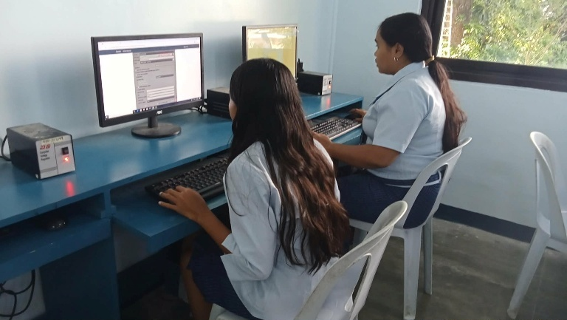
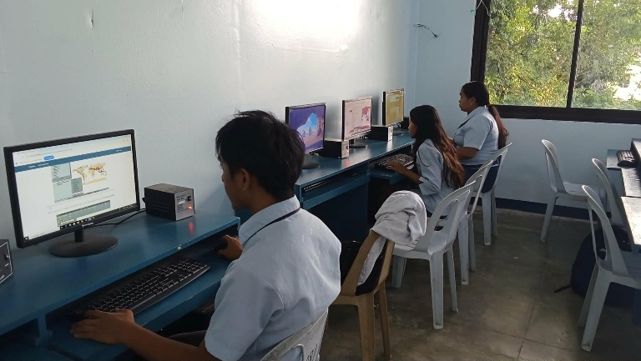
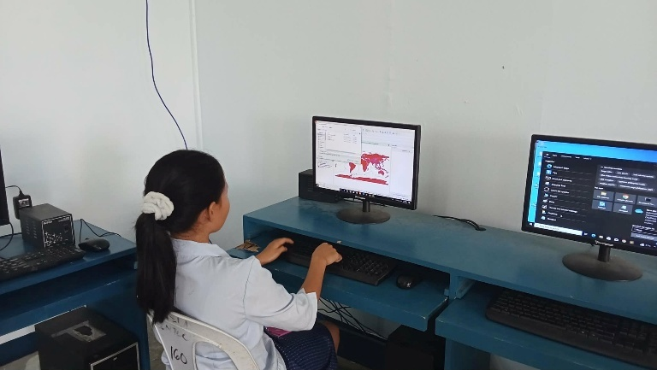

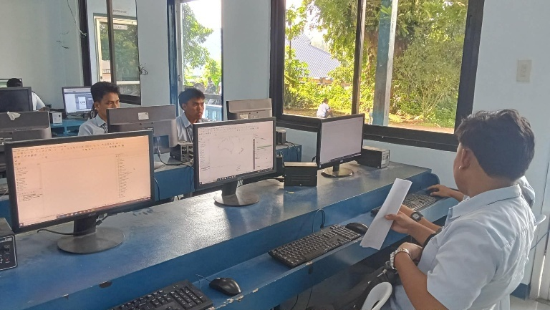

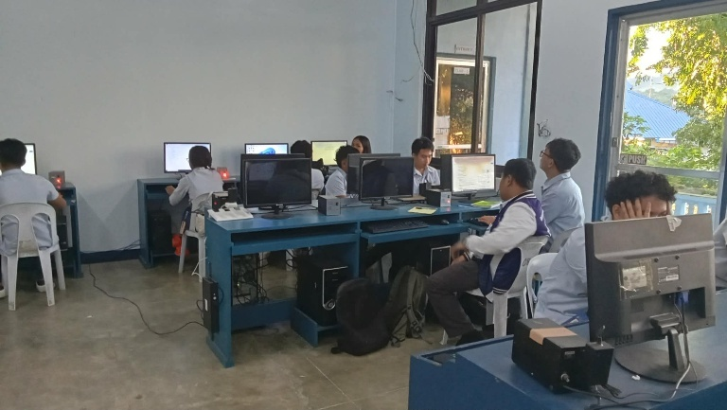
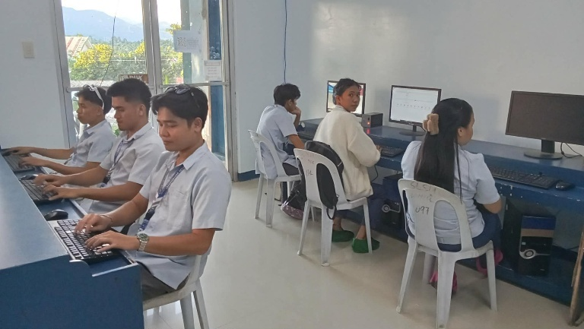
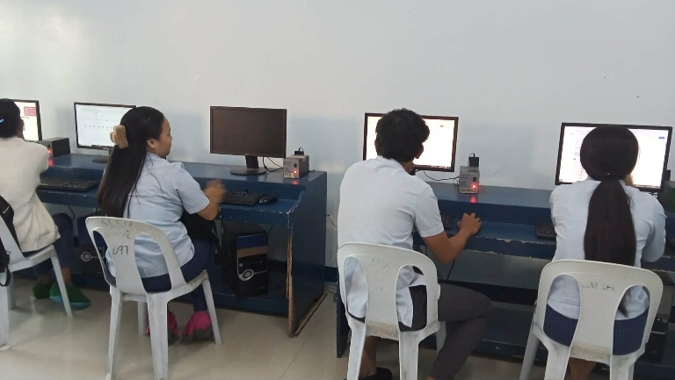
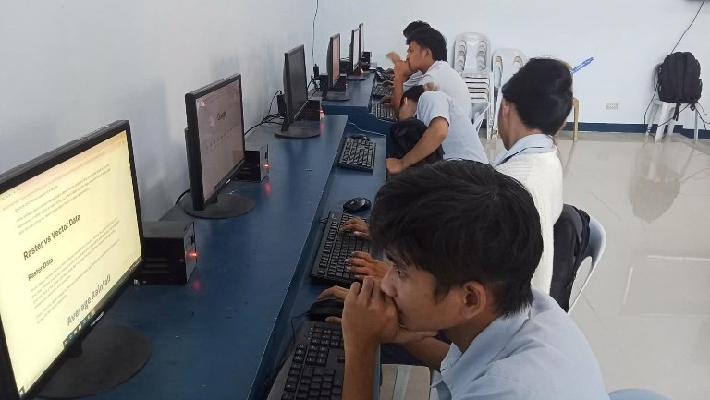

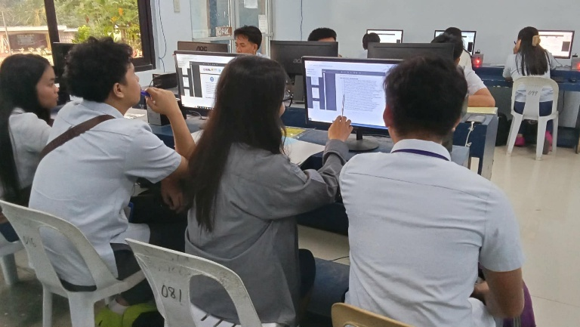
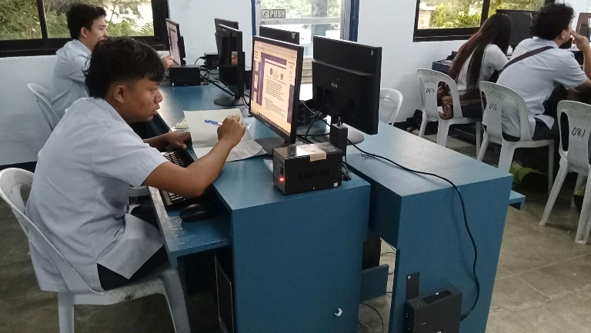
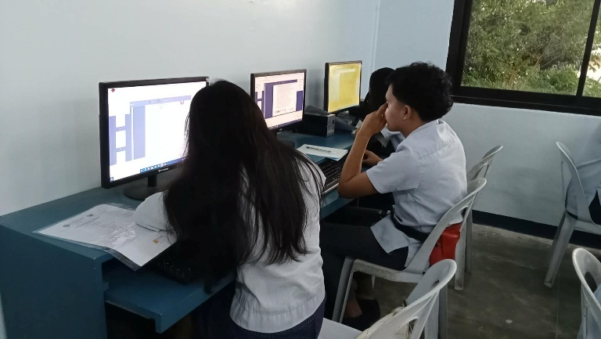
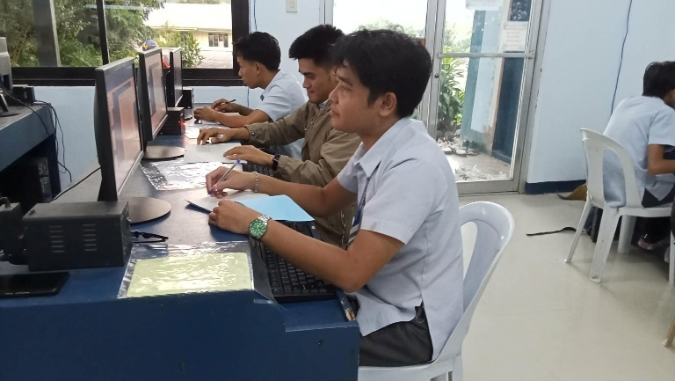

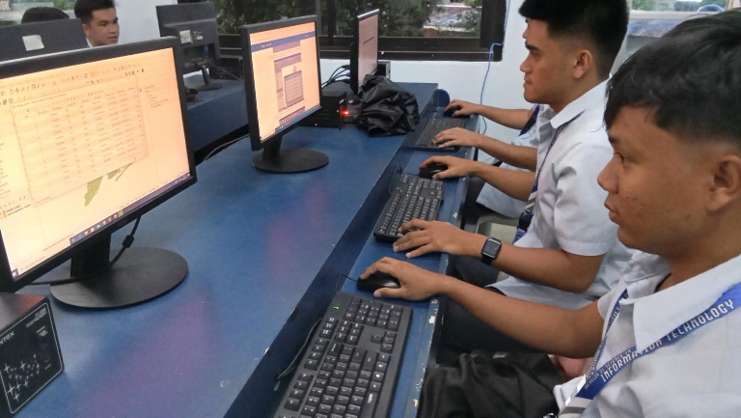
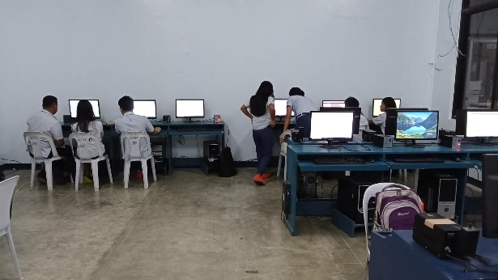
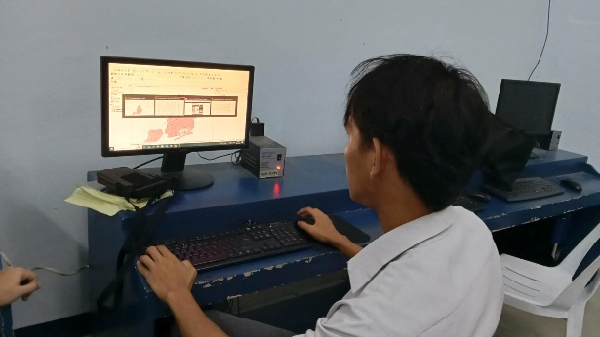

Prepared by: Approved:

JUNNIE RYH M. SUMACOT SHERWIN G. CADAY, PhD.
Instructor Program Chair

